**Project 1**

**SEO**

1. **Perform Keyword Research using a Keyword Planner:**

| villas in north bangalore | 5000 | High |
| --- | --- | --- |
| villas to buy in bangalore | 5000 | High |
| luxury apartments in bangalore | 5000 | Medium |
| luxury flats in bangalore | 5000 | Medium |
| best villa projects in bangalore | 500 | High |
| premium apartments in bangalore | 500 | High |
| luxury villas for sale in bangalore | 500 | High |
| villa with private pool | 500 | Low |
| private villa with private pool | 500 | Low |
| cheap villas with private pool | 50 | High |
| luxury villas | 500 | Low |
| gated community villas | 50 | Medium |
| private villas | 50 | Low |

1. **Create Meta Title and Descriptions**

1.

* **Meta Title**- Premium Villas for Sale | Luxury Living in Bangalore
* **Meta Description**- Discover exquisite premium villas in Bangalore. Experience luxury living with modern amenities, spacious designs, and exclusive community benefits.

2.

* **Meta Title**- Discover Exclusive Premium Villas for Sale | Luxury Living Redefined
* **Meta Description**- Explore our collection of premium villas designed for luxury living. Nestled in prime locations, these villas offer private pools, stunning views, and world-class amenities. Invest in your dream home today.

1. **Write a 600 word SEO Friendly Website Content**

**Find Your Dream Home: Premium Exclusive Villas for Sale**

Welcome to a world where luxury, comfort, and sophistication converge to create the ultimate living experience. At **SkyHaven**, we offer premium villas designed for individuals who desire excellence, privacy, and a modern lifestyle. These villas are located in prime areas, offering unmatched amenities, breathtaking views, and superior comfort. Whether you're looking for a permanent residence or a vacation retreat, our premium villas are the ideal choice for luxury living.

**Exceptional Luxury in High-Demand Locations**

Location is a key element of every real estate investment, and our premium villas are situated in the most sought-after areas. Whether it's a quiet countryside, a beautiful beachfront, or a bustling city, our properties offer proximity to top schools, shopping centers, entertainment, and recreational activities. Imagine waking up every morning to stunning views of nature or the city skyline, all while enjoying the luxury of your beautiful home.

These premium villas are located in gated communities that provide maximum privacy and tranquility. With 24/7 security, gated access, and advanced security systems, you can rest assured knowing that your home is well-protected.

**Contemporary Architecture & Design**

Our premium villas feature elegant, modern architectural designs that combine style and functionality. Each villa offers open floor plans, expansive windows, high ceilings, and open spaces that allow for an abundance of natural light. The exterior finishes are crafted from high-quality, eco-friendly materials that offer both beauty and sustainability.

Whether you prefer a minimalist modern design or a lavish, deluxe style, our diverse property catalog includes homes that cater to every taste. We also offer customization options to ensure your villa aligns with your personal preferences and style.

**Resort-Style Amenities**

Owning one of our premium villas means access to an array of resort-style amenities. For those who enjoy the luxury of their own private space, our villas come equipped with features like private pools and in-house gyms. Smart home technology allows you to control lighting, temperature, and security from your smartphone, ensuring convenience at your fingertips.

Many of our villas also feature beautifully landscaped gardens, outdoor dining and BBQ areas, and entertainment spaces designed for relaxation and social gatherings. Enjoy a swim in your private pool, dine al fresco, or simply relax among the fragrant blooms of your private courtyard.

**Sustainable Living**

Sustainability is at the heart of our premium villas. We incorporate green building materials and eco-friendly features without sacrificing luxury and comfort. Our villas are equipped with solar panels, energy-efficient systems, and rainwater harvesting systems, making them not only luxurious but also environmentally conscious.

By choosing one of our villas, you’re investing in a high standard of living while contributing to a sustainable future.

**A Smart Investment**

Investing in luxury real estate goes beyond creating a sanctuary; it’s a smart investment for your future. Our premium villas are located in areas poised for significant economic and population growth, ensuring the value of your investment appreciates over time. Whether you plan to use the villa as your family home or part of your investment portfolio, these properties offer long-term financial benefits.

Luxury real estate has consistently proven to be a solid investment, regardless of economic fluctuations. When you invest in a premium villa, you’re securing both financial stability and the joy of owning a high-end property.

**Why Choose Us?**

At **SkyHaven**, we pride ourselves on delivering the highest industry standards and unparalleled customer service. Our team of real estate professionals is here to guide you through every step of the buying process, ensuring a seamless and hassle-free experience. We understand that purchasing a luxury home is a significant investment, and we’re committed to helping you find the perfect property that exceeds your expectations.

**Take the First Step Toward Your Dream Home**

Are you ready to experience luxury living at its finest? Contact us today to schedule a viewing of our exclusive premium villas. Our team is ready to answer any questions and assist you in finding the ideal property to suit your lifestyle and needs.

Don’t miss out on this rare opportunity to own a piece of paradise. Book a tour of our premium villas today and make your dream home a reality.

1. **Write a 1000 word Blog to promote the property**

**Discover the Luxury of SkyHaven: Your Dream Villa Awaits**

Imagine waking up every day in a luxurious villa surrounded by breathtaking views, modern amenities, and complete privacy. A place where elegance meets comfort, and where you can relax, entertain, or simply enjoy the beauty of your surroundings. This is what **SkyHaven** offers – a premier real estate development that provides a selection of exclusive premium villas for discerning homeowners who seek the best in luxury living.

In this blog, we'll take a closer look at what makes **SkyHaven** a standout choice for luxury property buyers, from its prime locations and exceptional architectural designs to its world-class amenities and sustainable features.

**The Pinnacle of Luxury Living**

At **SkyHaven**, luxury isn't just a word – it’s a way of life. The villas are thoughtfully designed to provide a seamless blend of sophistication, comfort, and modern functionality. Each villa is situated in a prime location, allowing homeowners to enjoy the beauty of their surroundings, whether it's a scenic countryside, a serene beachfront, or a bustling urban center.

**SkyHaven** villas are built for those who desire more than just a home. These properties are ideal for individuals who appreciate privacy, exclusivity, and the finer things in life. Whether you're looking for a permanent residence or a vacation home, **SkyHaven** offers a unique living experience that’s hard to find anywhere else.

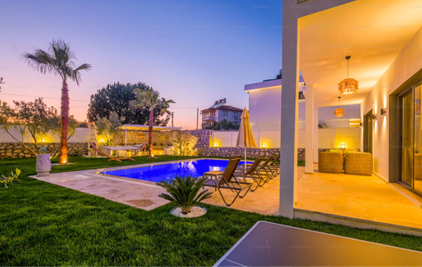

**Prime Locations for the Perfect Lifestyle**

One of the key factors that set **SkyHaven** apart from other luxury developments is its strategic location. Every **SkyHaven** villa is nestled in a high-demand area, offering convenient access to essential services, entertainment, and recreational activities. Whether you prefer the peaceful serenity of the countryside, the vibrancy of the city, or the beauty of a beachfront property, **SkyHaven** has something for everyone.

* **Urban Luxury**: For those who prefer the excitement of city life, **SkyHaven** also offers villas in bustling urban areas. These villas are located near shopping districts, entertainment hubs, and top-tier schools, making them ideal for families or professionals who want to enjoy the best of both worlds – luxury living in the heart of the city.
* **Countryside Retreat**: If tranquility and peace are what you seek, **SkyHaven**’s countryside villas offer the perfect escape. Surrounded by nature, these villas provide a serene environment where you can relax and unwind, away from the noise and hustle of city life.

**Architectural Excellence and Modern Design**

**SkyHaven**’s premium villas are more than just homes – they are works of art. Each villa is meticulously designed with modern architectural principles in mind, combining sleek lines, open spaces, and contemporary aesthetics. The result is a home that not only looks stunning but also provides the ultimate in comfort and functionality.

* **Open Floor Plans**: All **SkyHaven** villas feature open floor plans that allow for maximum use of space and natural light. The large windows and high ceilings create an airy, spacious environment that feels welcoming and comfortable.
* **Customizable Designs**: Every homeowner is different, which is why **SkyHaven** offers customization options for its villas. Whether you prefer a minimalist modern style or a more opulent design, **SkyHaven** has a range of options to suit your personal taste. Customization allows you to create a home that reflects your individual style and preferences.
* **Eco-Friendly Materials**: Sustainability is a key focus at **SkyHaven**, and every villa is built using eco-friendly materials that minimize environmental impact. From energy-efficient insulation to sustainable building practices, **SkyHaven** is committed to creating luxury homes that are as kind to the planet as they are beautiful.

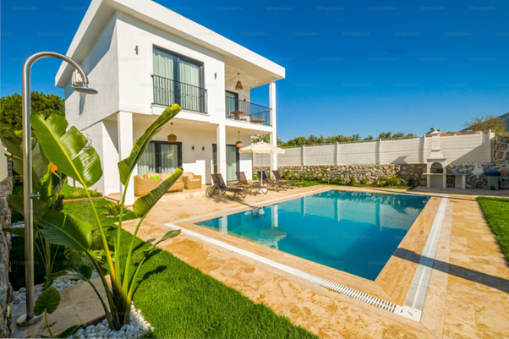

**World-Class Amenities at Your Fingertips**

Living at **SkyHaven** means enjoying a range of world-class amenities designed to elevate your lifestyle. From private pools to high-tech security systems, **SkyHaven** villas are equipped with everything you need to enjoy luxury living at its finest.

* **Private Swimming Pools**: What could be better than taking a dip in your own private pool on a hot summer day? **SkyHaven** villas come with beautifully designed pools that are perfect for both relaxation and entertaining guests.
* **In-House Gyms**: Stay fit without ever leaving your home. **SkyHaven** villas are equipped with state-of-the-art in-house gyms, allowing you to work out at your convenience.
* **Smart Home Technology**: Control your home with the touch of a button. **SkyHaven** villas feature smart home technology that allows you to manage lighting, temperature, security, and more from your smartphone or tablet.
* **Outdoor Entertainment Areas**: Enjoy alfresco dining in your beautifully landscaped garden, complete with outdoor BBQ areas and seating for entertaining guests. **SkyHaven**’s villas are designed with outdoor living in mind, providing the perfect space for hosting friends and family.

**A Commitment to Sustainable Living**

**SkyHaven** believes that luxury and sustainability should go hand in hand. That’s why each villa is designed with eco-friendly features that reduce environmental impact without compromising on comfort or style. From solar panels to energy-efficient appliances, **SkyHaven** villas are built for a greener future.

* **Solar Energy**: All **SkyHaven** villas come equipped with solar panels, reducing reliance on traditional energy sources and lowering your carbon footprint.
* **Rainwater Harvesting**: **SkyHaven** villas are equipped with rainwater harvesting systems that collect and recycle rainwater, providing a sustainable source of water for landscaping and other uses.
* **Energy-Efficient Systems**: From lighting to heating and cooling, **SkyHaven** villas are equipped with energy-efficient systems that help reduce energy consumption while keeping your home comfortable.

**Why Investing in SkyHaven is a Smart Choice**

Purchasing a villa at **SkyHaven** isn’t just about owning a beautiful home – it’s a smart investment. Luxury real estate has long been considered one of the most stable and profitable investments, and **SkyHaven’s** premium villas are no exception. Located in high-growth areas, these properties are poised for significant value appreciation over time.

* **High ROI Potential**: **SkyHaven** villas are situated in areas with strong economic growth and increasing property values, ensuring that your investment will continue to appreciate in value over the years.
* **Rental Income Opportunities**: If you’re not planning to live in your villa year-round, renting it out can provide a lucrative source of income. **SkyHaven**’s premium villas are highly sought after, making them ideal for the luxury rental market.

**Your Dream Home Awaits at SkyHaven**

If you’re looking for a home that combines luxury, comfort, and sustainability, look no further than **SkyHaven**. With its prime locations, modern designs, and world-class amenities, **SkyHaven** offers the ultimate in luxury living. Whether you’re seeking a permanent residence or a vacation home, **SkyHaven** has the perfect villa for you.

Don’t miss out on the opportunity to own a piece of paradise. Contact us today to learn more about our exclusive premium villas and take the first step toward finding your dream home at **SkyHaven**.

<https://wireframe.cc/ysLvqQ>

**SEM**

1. **Keyword Research using keyword planner with average bid value**

| **Keyword** | **Avg. monthly searches** | **Competition** | **Top of page bid (low range)** | **Top of page bid (high range)** |
| --- | --- | --- | --- | --- |
| villas in bangalore | 50000 | Medium | 56.02 | 163.34 |
| house sale bangalore | 50000 | Medium | 8.22 | 107.02 |
| house for sale in bangalore city | 50000 | Medium | 8.22 | 107.02 |
| luxury villa | 5000 | Low | 11.19 | 47.32 |
| villa with pool | 5000 | Low | 5.03 | 23.81 |
| villa in bangalore for sale | 5000 | High | 59.16 | 156.34 |
| villa with private pool | 5000 | Low | 5.03 | 20.03 |
| villas in sarjapur | 5000 | Medium | 91.63 | 200.04 |
| villas in whitefield | 5000 | Medium | 61.14 | 152.25 |
| villas in north bangalore | 5000 | High | 76.73 | 222.31 |
| luxury villas in bangalore | 5000 | Medium | 61.94 | 184.44 |
| buy villa in bangalore | 5000 | High | 59.16 | 156.34 |
| individual house for sale in bangalore | 5000 | Medium | 6.88 | 78.57 |
| private villa with private pool | 5000 | Low | 5.03 | 20.03 |
| villas for sale in whitefield | 5000 | Medium | 54.07 | 138.33 |
| row houses in bangalore | 5000 | Medium | 43.09 | 132.05 |
| pool villa | 5000 | Low | 5.87 | 20.87 |
| villas for sale in bangalore whitefield | 5000 | Medium | 54.07 | 138.33 |
| poolside villa | 5000 | Low | 5.87 | 20.87 |
| villas in bangalore whitefield | 5000 | Medium | 61.14 | 152.25 |
| villa with swimming pool | 5000 | Low | 5.03 | 23.81 |

1. **Implement Keyword Match types**

### **Broad Match:**

* villas in bangalore
* house sale bangalore
* villa with pool
* private villas
* gated community villas
* best villa projects in bangalore
* luxury villas in bangalore
* buy villa in bangalore
* poolside villa

### **Phrase Match (using quotes " "):**

* "villas in bangalore"
* "house for sale in bangalore city"
* "luxury villa"
* "villa in bangalore for sale"
* "private villa with private pool"
* "villas in whitefield"
* "villas in sarjapur"
* "villas for sale in bangalore whitefield"

### **Exact Match (using square brackets [ ]):**

* [villas in north bangalore]
* [villas for sale in bangalore]
* [individual villas for sale in bangalore]
* [villas for sale in whitefield]
* [villa with private pool]
* [pool villa]

**Negative Match**

* rent (e.g., "villa for rent", "house for rent")
* cheap (e.g., "cheap villas", "affordable houses")
* free (e.g., "free property listings", "free villas")
* lease (e.g., "lease villas", "lease property")
* room (e.g., "single room", "2BHK rooms")
* villas in Mumbai
* villas in Delhi
* villas in Chennai
* villas in Pune

1. **Design Landing Page wireframe**

<https://wireframe.cc/ysLvqQ>







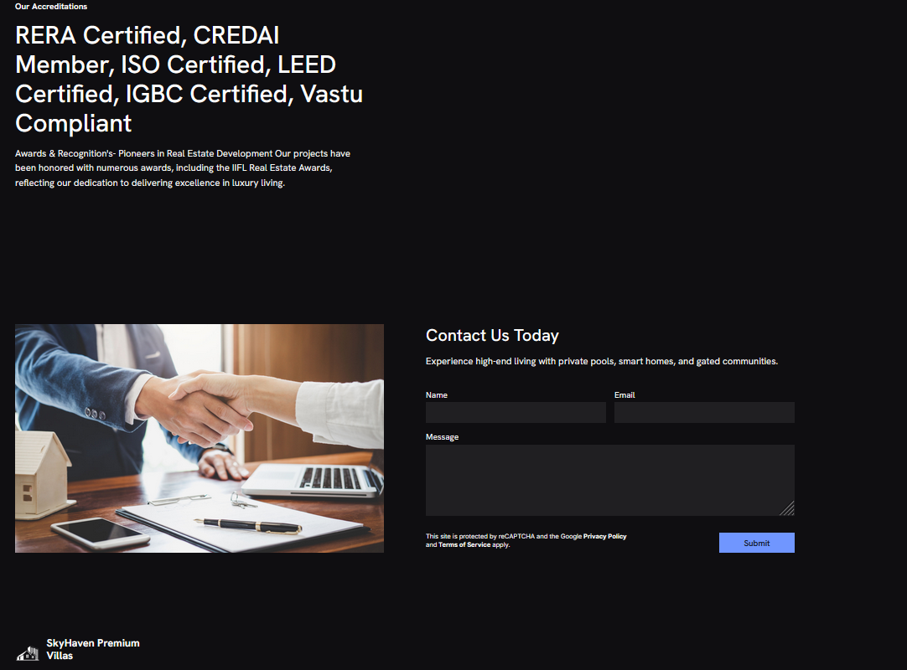

1. **Google Ad Simulation**





